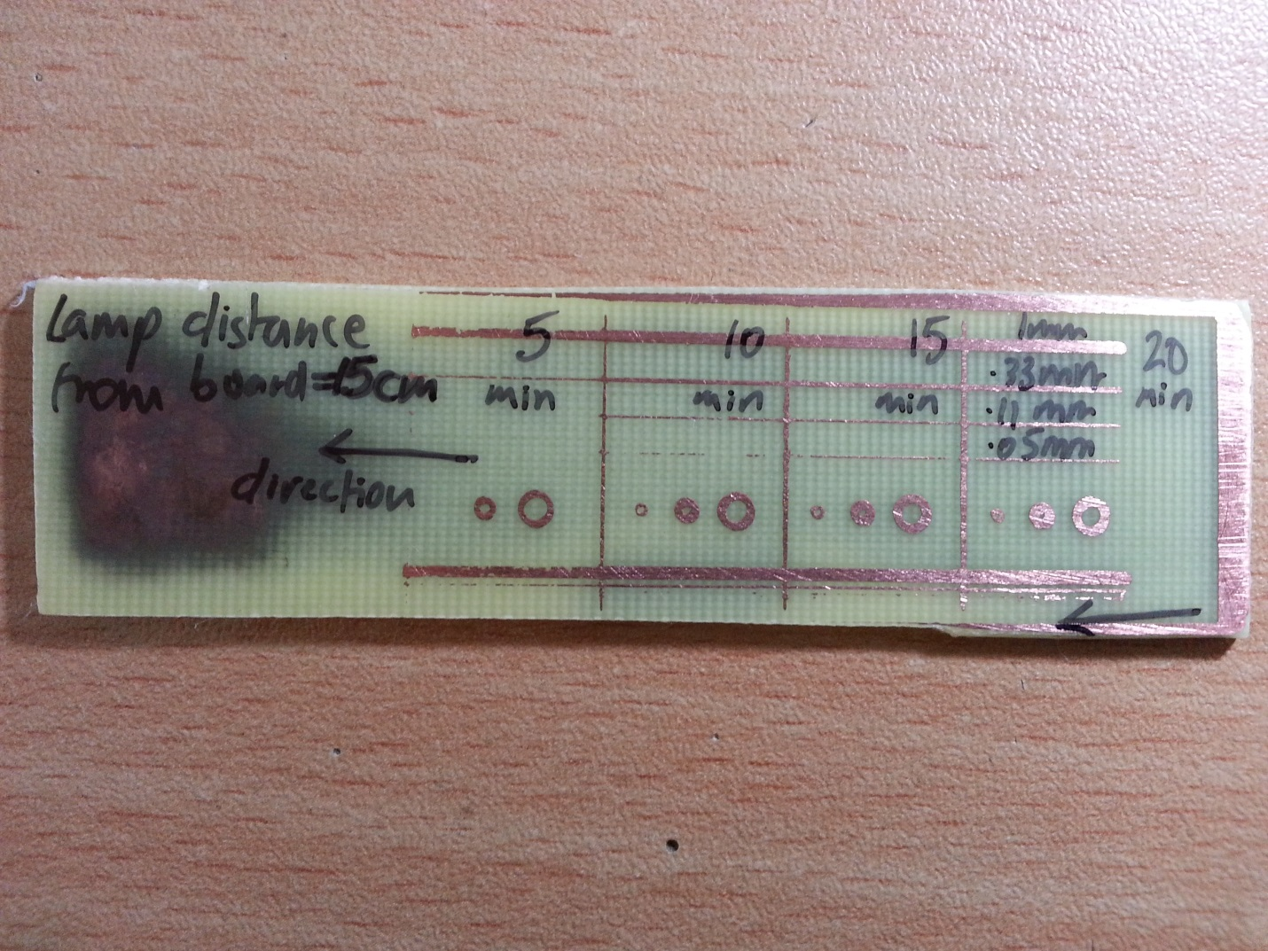

1. Print the TOP layer as mirror so that you can put the printed side of the transparency right on the PCB face. No gap!
2. Transparency Sheet – while printing, put the side with the paper protective covering facing top in the printer
3. Print in the middle on the transparency as the sides get seared and smudged while printing
4. The TOP RIGHT of the print image is printed on the TOP RIGHT corner of the page in the printer feed tray facing up
5. Ideal PCB exposure parameters:
   1. TIME : 30-35 minutes
   2. DISTANCE OF TABLE LAMP FROM GLASS : 18cm
   3. MIN TRACE WIDTH : 0.11mm (ideal = 0.33mm)
   4. MIN TRACE GAP : 0.32mm
   5. VIAS
      1. MIN – OUTER : 1mm
      2. MIN – INNER : 0.486mm

**BETTER DIPTRACE PARAMETERS**

1. VIAS
   1. Outer : 1.6mm
   2. Inner : 0.3mm
2. PADS
   1. SQUARE (caps, crystals etc)
      1. W x H = 1.8mm x 1.8mm
      2. Hole : Round = 0.6mm
   2. CIRCLE (caps, crystals etc)
      1. W X H = 1.8mm x 1.8mm
      2. Hole : Round : 0.6mm
   3. TRANSISTOR PADS
      1. W x H : Oval Through Hole : 3mm x 1mm
      2. Hole : Round = 0.6mm
   4. BIG PADS (8*8 led matrix etc)
      1. W x H = Oval Through Hole : 2mm x 5mm
      2. Hole : Round = 0.6mm
   5. DC BARREL JACK
      1. W x H : Oval Through Hole : 3mm x 5mm
      2. Hole : Oval : W x H = 1mm x 2.5mm
3. TRACK WIDTH
   1. Default = 0.33mm = 13 mil
   2. For better result try with 16mil – 17mil

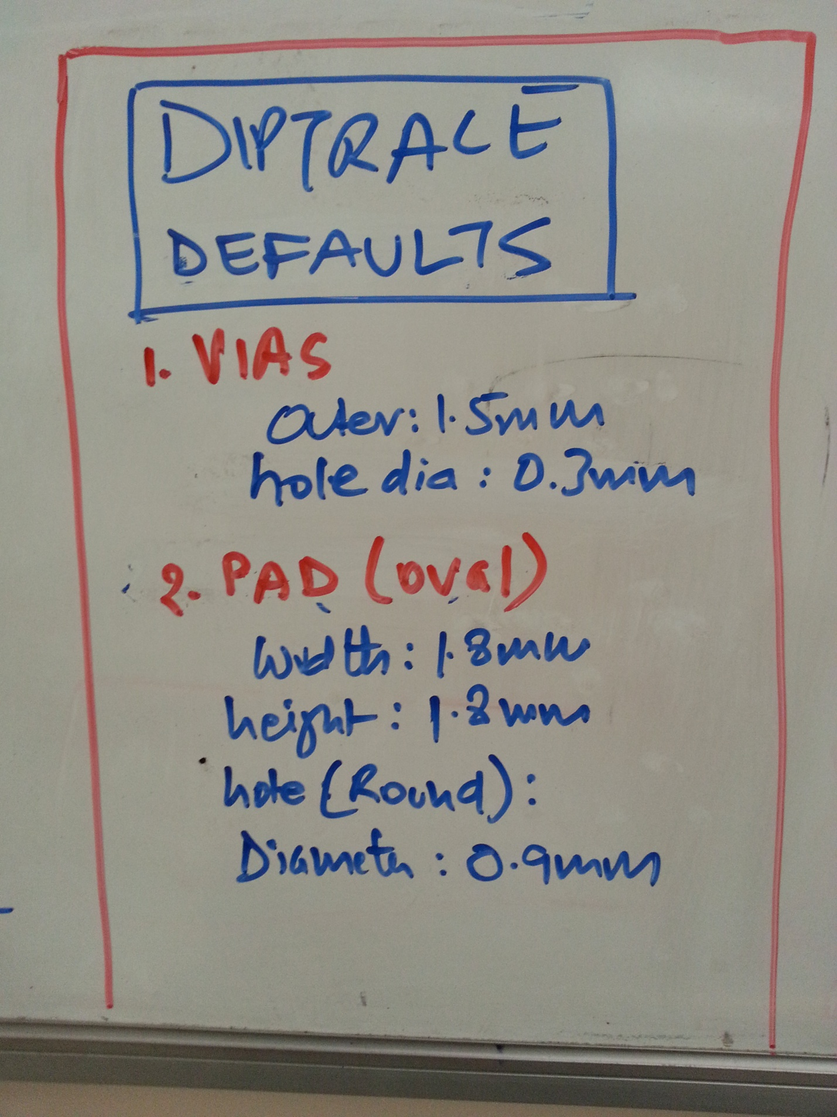

**PARCHMENT PAPER**

1. When parchment paper not available can also use the thin tracing paper type that is there in between the transparency sheets to prevent scratching. **Although this paper is porous so it leaves copper specs or dots on the finished pcb**.
2. With this paper, **print on the non-wax/glassy side and select the paper type as transparency + economode turned off** for best results.
3. With this paper **the contrast is good enough so that only need 1 sheet per pcb layer. So no more printing 2 transparencies of the same layer and aligning them**.
4. **Was able to get down to following parameters**
   1. **Trace width : 10 mil (0.254mm)**
   2. **Vias : outer = 1.5mm , inner = 0.3mm**
5. **Since parchment paper is thin, do not put it directly in the printer, it’ll melt or wrap or get stuck. Instead stick a piece of parchment paper on a regular a4 paper using masking tape to give it support and then put that in the printer**

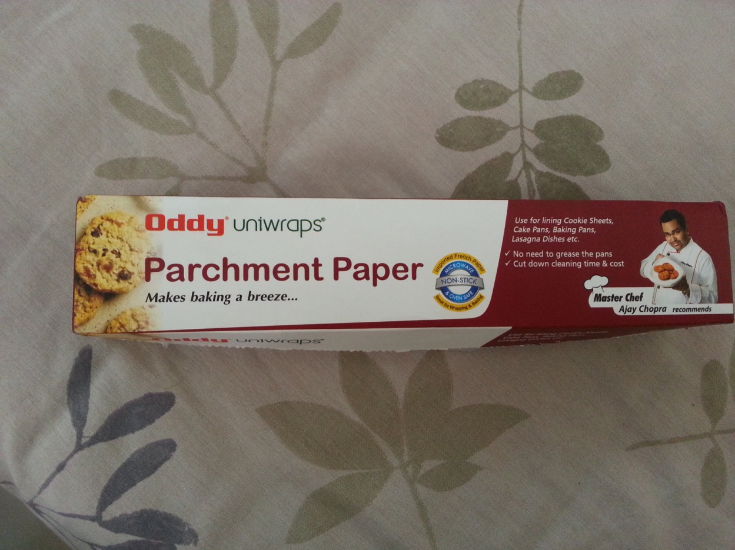

**This is the parchment paper I use. Bought from Amazon for Rs 200 (shipping included). Paste this on a regular A4 paper using masking tape to print on it. Print with regular paper settings.**

**GOT AWESOME RESULTS WITH PARCHMENT PAPER. FROM NOW ON USE THIS ONLY ☺**

**NOTE : WHEN PRINTING ON PARCHMENT PAPER, PRINT THE BOTTOM LAYER AS MIRROR (ALONG WITH THE USUAL OF DOING NEGATIVE ON BOTH LAYERS) SO THAT THE PRINTED SIDE OF THE BOTTOM LAYER IS ON THE OUTSIDE RATHER THAN INSIDE WHEN MAKING THE SHEL FOR THE BARE PCB FOR UV TREATMENT.**

**NOTE : FOR THE SOLDER MASK, ITS STILL BETTER TO USE TRANSPARENCIES INSTEAD OF PARCHMENT PAPER, AS WITH PARCHMENT YOU CANT SEE WHERE EXACTLY THE HOLES ARE. ITS TOO OPAQUE FOR THIS PURPOSE. FOR THIS USE TRANSPARENCY ONLY.**

|  |
| --- |
| **TOP BOTTOM SIGNAL LAYER : PARCHMENT PAPER TOP BOTTON SOLDER MASK LAYER : TRANSPARENCY SHEET** |